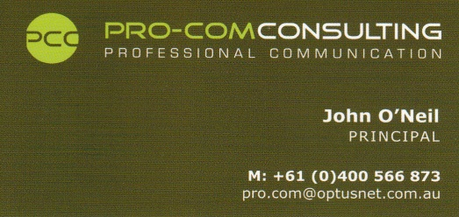
The business
Established in 2005 and based in Melbourne, Pro-Com Consulting designs, develops and delivers purpose built communications programs to Government and corporate clients. Projects include the development and roll-out of a new communications package for the Australian Customs Service nationally and more recently developing crisis negotiation capability for specialist groups within Australian law enforcement agencies. Recent corporate clients have included Melbourne sports and entertainment complex staff. Pro-Com does not advertise and relies only upon good reputation and word within the law enforcement, military and private sectors from those exposed to the program.
The product
The program is ‘Adaptive Communication’ and although purpose designed to fit the needs of the client its core is based upon proven crisis negotiation principles and tactics. The system represents a major shift away from step- based communications systems typically adopted by most law enforcement agencies. Pro-Com philosophy is ‘talk naturally, think tactically’ and is based on the elements of adaptability, awareness, strategy and delivery. It employs a concept of approach known as ‘REAL‘ and focuses on communication as the preferred use of force option. Whilst the system does not claim to resolve every encounter through communication alone it provides an enhanced capability and greater prospect of resolution through effective communication presence and maintenance.
Adaptive communication is designed to address incidents ranging from public relations encounters to vehicle intercepts to critical incidents and crisis negotiation.
The people
Pro-Com prides itself in the quality of its staff and associates, employing only those with extensive experience and proven records in police negotiation and tactical units. It is the people, their depth of knowledge, passion for their trade and demonstrable experience in the field that ensure the product maintains currency and quality.
John O’Neil presents from a military and policing background. Of his 17 years with Victoria police John spent 8 in the Police Hostage Negotiator Unit. Having attended in excess of one hundred critical incidents as primary negotiator or team leader he joined the police negotiator training team. John conducted courses of instruction in the field for not only Victoria Police centrally and regionally but for Department of corrections (CORE) and military reserve forces in addition to providing private service to Department of Human Services and major banking groups. John has been fortunate enough to have trained with negotiator personnel from the FBI Academy and Scotland Yard.
Holding a National CT negotiator qualification since 1996 John has trained with Police Negotiator Units all around the Country. In 2003 he was selected to attend in the Philippines as part of a joint training team for the Australian Federal Police to conduct a two week course in Hostage Negotiation for the Philippine National Police and Armed Forces of the Philippines. It was the first of its kind.
Moving on from Victoria Police in late 2004 John founded Pro-Com Consulting and developed the Adaptive Communication package. John continues to work in Australian Law Enforcement and conducts training for police and private clients.
Neil STEWARD brings over 27 years of policing experience to the business. Leaving Victoria Police in 2009 and previously in charge of the negotiator unit, Neil left as Victoria Police' most senior negotiator. With 23 years of negotiator experience, qualifying in 1985 and having attended literally hundreds of critical incidents, Neil was instrumental in developing the Unit’s capability and building its reputation as able to stand aside the best units in the world. Highly regarded within the negotiator community and one of only a handful of qualified CT negotiator coordinators and an NCTC instructor Neil s’ record speaks for itself. In demand as private consultant and public speaker, he has trained with Police negotiators from all around the world and now offers that experience and knowledge to various clients as part of the Pro-Com training team.
Mark PLUMB joins Pro-Com from a policing background with over 15 years in the trade and prior to that as a high school physical education teacher. Mark, an ex-police negotiator with Victoria Police also conducts his own business providing a professional role-play service to the policing and security industry and various clients. Mark is an experienced instructor who currently remains in the law enforcement field.
In addition to police negotiator expertise, Mark, Neil and John also have many years instructing in other disciplines including close personal protection, riot response, crowd control and critical incident management.
The combined experience pool of people in the Pro-Com team is extensive, totally more than 150 years in the field of law enforcement and is committed to ensuring the highest level of product.

