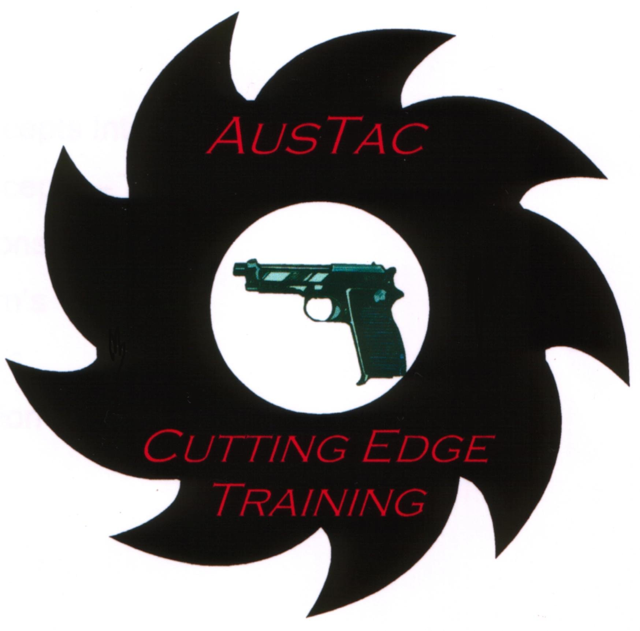

AusTac International

Mission
Simply stated, our Mission is to provide armed professionals with the highest-quality realistic & operationally specific training possible - to enable you to prevail in high-risk environments.

Background
Even though our training and simmunition methodology is unique our operational doctrine is not specifically "ours"; it is however a synthesis of what is in the environment, revealed through many years of intense training and actual operations. Our staff members frequently interact, operate and train with law enforcement and military professionals within the first responder and special operations communities. All staff members have many years of experience in serving as law enforcement and military operators as well as having years of experience instructing military and law enforcement professionals.

As a result our courses development has been based on years of experience, feedback and real world missions. As such our training will continue to evolve and change over time as we interact with those that go in harms way and find more efficient ways of training and operating in response to changing mission requirements or criminal trends.

Course Methodology
AusTac believe that conducting training that is simply a check the box or attendance only style is futile, unproductive and dangerous, (we leave that style of training to your employer). We prefer to offer courses that are a wise investment for the serious operator wishing to increase proficiency and the probability of prevailing in a real world, high risk environment in which adversaries think, move and shoot back.

As such our courses feature a very demanding “Force-on-Force training” approach. Reasons for this include the following:

- Allows the participant to train classroom taught principles and techniques in an operationally specific manner.
- Allows the participant to test that what they have been trained in previously will be successful in a realistic simulation of a realistic engagement(s)
- Allows the participant to operate, perform and effectively manage critical skills necessary to succeed while the “Sympathetic Nervous System” is activated.
- Allows the participant to test new equipment, technology, strategies, principles, tactics and techniques in a variety of environments with diverse environments and adversaries.
- To acclimatize the sub-conscious to the stresses of realistic engagements and to ingrain within the sub-conscious conditioned stimulus and conditioned response.

Training Commitment
Austac International staff will fully participate in the course and are required to maintain a “show you” capability; nothing required of the students will fall outside of the following sequence:

- Tell You – Show You - Allow You – Evaluate Performance – Repeat -

We employ multimedia, handouts, note taking sheets, video review, practical drills, scenarios and full-mission profiles to expose you to maximize your training experience.

Staff members serve as instructors, mentors, and will always strive to maintain a teachable attitude. Staff will serve you as instructors, mentors coaches in an endeavour to make you the best you can be.

Staff will be a ready reference – available on call 24 hrs a day.

Staff members fully participate in role-playing as officers, suspects, & combatants.

We stress reality in training and it is our way of doing business, it is a way in which we train with our students, (friends) and not ‘lecture at you from on high’. We believe the learning journey for operating in high risk environments never ends and that we as instructors remain perpetual students. We also strongly believe that if we recommend a technique it better work in the real world and we as instructors need to be able to demonstrate what we are talking in real time.

Training with AusTac International

In order to ensure high-quality and meaningful training to all those attending AusTac International courses, please review and carefully consider each statement below prior to submitting your expression of interest in attending this course

1. AusTac International was founded out of a strong desire to provide extremely realistic combative training as relates to law enforcement situations and military close quarter combat engagements.

2. Our courses are not administrative in nature, they are specifically designed to place individuals and teams under the type of duress that closely simulates the stress of real-world engagements. We believe that the harsh demands of operating in operational environments require a similarly demanding training curriculum. Our courses are for serious operators, they are not attendance only courses and are not suitable for those wishing to simply check the box for another certificate.

3. Our courses are designed to impart a genuine capability to those who intend on bringing the data, concepts, tactics and training methodologies back to their respective departments or fellow operators.

4. Based on this foundation, training as delivered through AusTac International is physically, mentally and emotionally challenging. The Force-on-Force training is mentally challenging, often painful, but not permanently damaging to the body.

5. Due to the tremendous volume of information and practical exercises, drills, and scenarios, all AusTac International courses that include rigorous Force-on-Force will typically be 10-12 hours in duration.

6. This is not a physical fitness course per se, but it is highly recommended that you work on your flexibility, body-weight to strength ratio, and have reasonable cardiovascular fitness before participating in this type of training. We believe this is sound doctrine for anyone who carries firearms professionally. Those that are obese, unfit or lack the necessary mental fortitude and attitude to realistic training will have constant difficulties during the entire training course and should not attend.

7. Those attending training should arrive on day one mentally prepared to receive new concepts, (leave your ego at home). They should be prepared to give them a fair evaluation and demonstrate a strong spirit to apply them during the practical training blocks. Training is intended to demonstrate new concepts and principles, new ways of problem solving, create a close interaction with fellow students, illustrate the principles of combat, provide principle-based and technically sound solutions to commonly faced attacks.

8. AusTac International and those students attending our courses would rather you decline this training opportunity if you are not FULLY prepared to work EXTREMELY HARD during training. Our training staff has already made this commitment to those who are spending the time, money, and effort to improve their tactical capabilities.

Thanks to Strategos International for their influence and thoughts on reality based training.

